Name - Aniket Narale

OOPS Assignment

Q1. Write a singleton class. Confirm that singleton class cannot be inherited.

Singleton Class:-

The singleton design pattern is used to restrict the instantiation of a class and ensures that only one instance of the class exists in the JVM. In other words, a singleton class is a class that can have only one object (an instance of the class) at a time per JVM instance.

**Singleton Class in Java**

In object-oriented programming, a singleton class is a class that can have only one object (an instance of the class) at a time.

After first time, if we try to instantiate the Singleton class, the new variable also points to the first instance created. So whatever modifications we do to any variable inside the class through any instance, it affects the variable of the single instance created and is visible if we access that variable through any variable of that class type defined.

Remember the key points while defining class as singleton class that is while designing a singleton class:

* Make constructor private.
* Write a static method that has return type object of this singleton class. Here, the concept of Lazy initialization is used to write this static method.

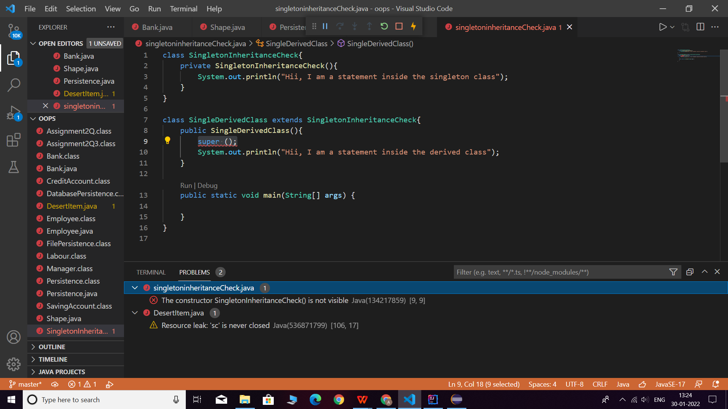

**Note:** As we can see that we are trying to inherit the singleton class which has a private access as the constructor which is defined is private. So this code will produce an error saying “SingletonInheritanceCheck() has private access in SingletonInheritanceCheck”.

Valid Program for Singeton Class-

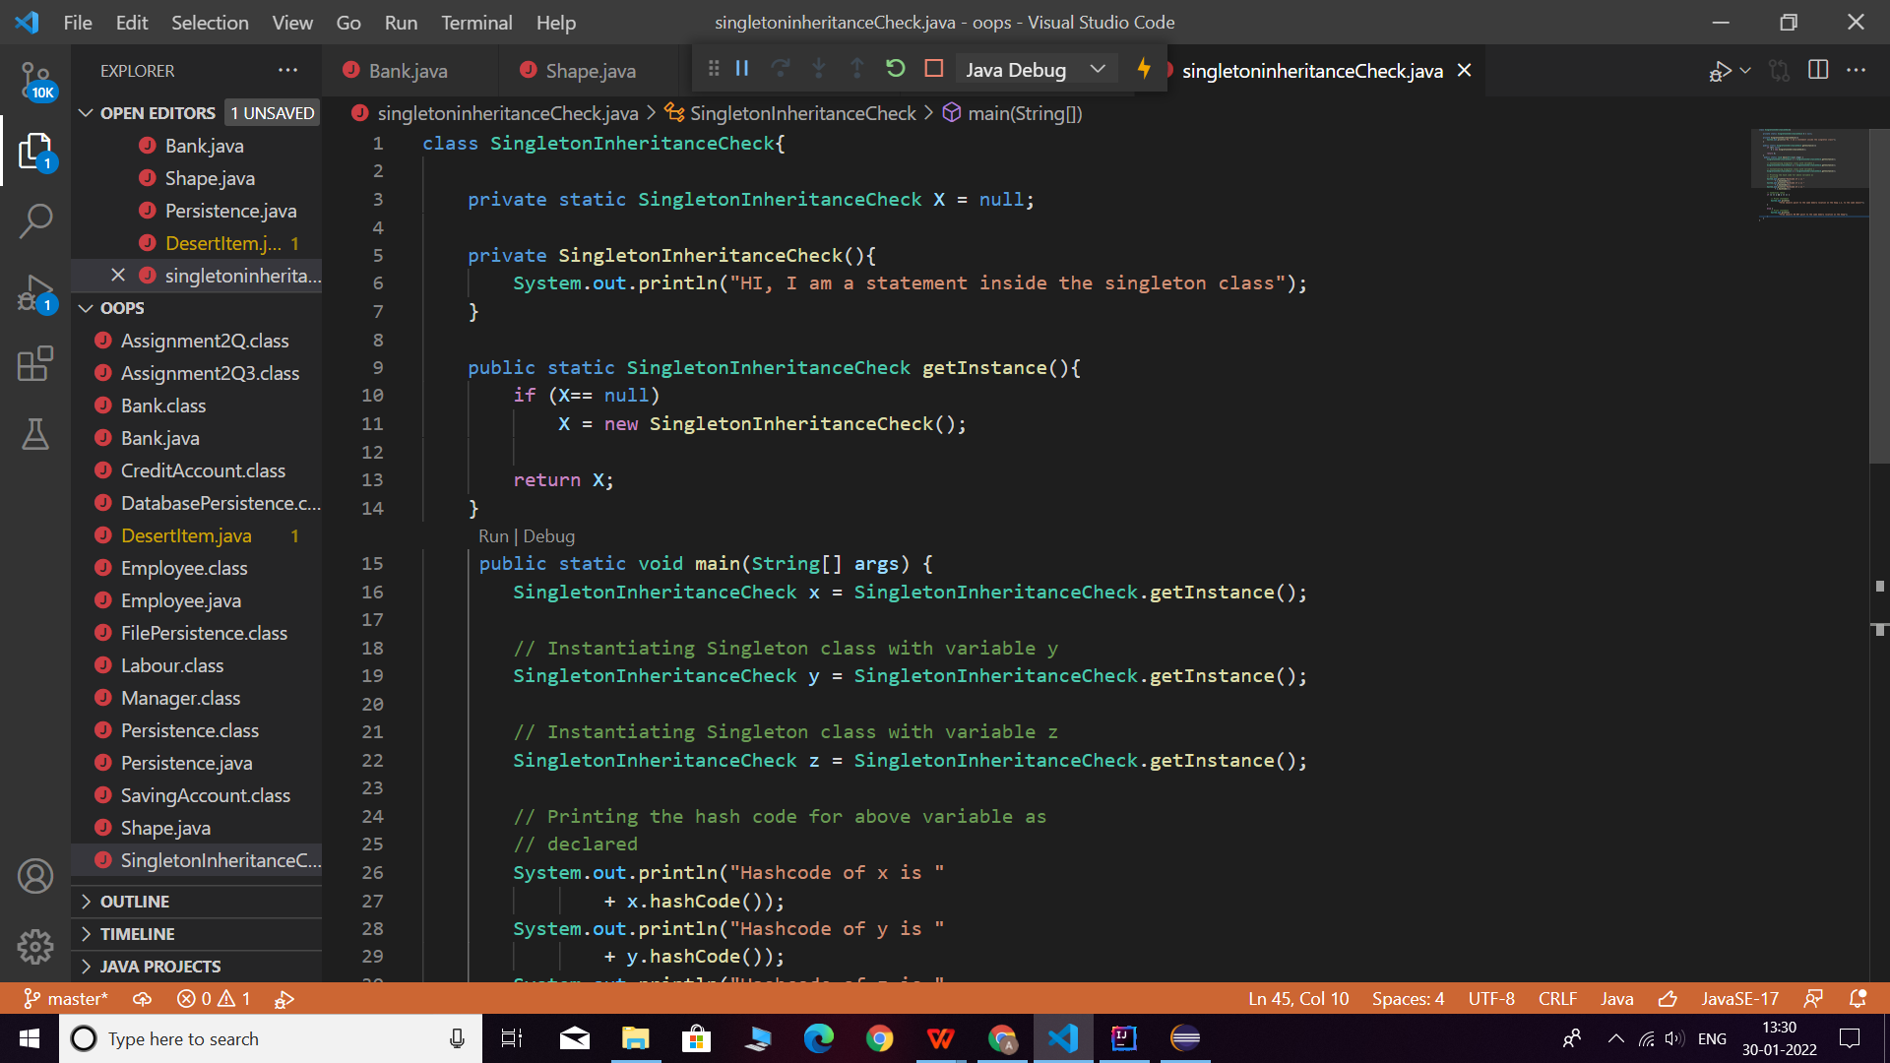

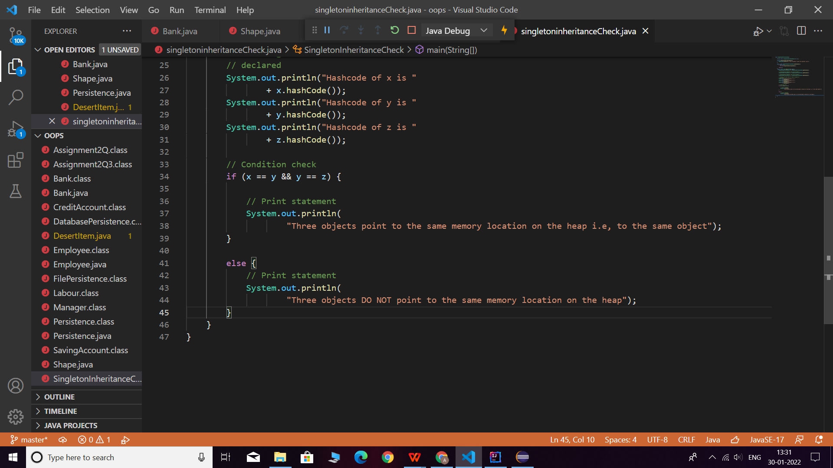

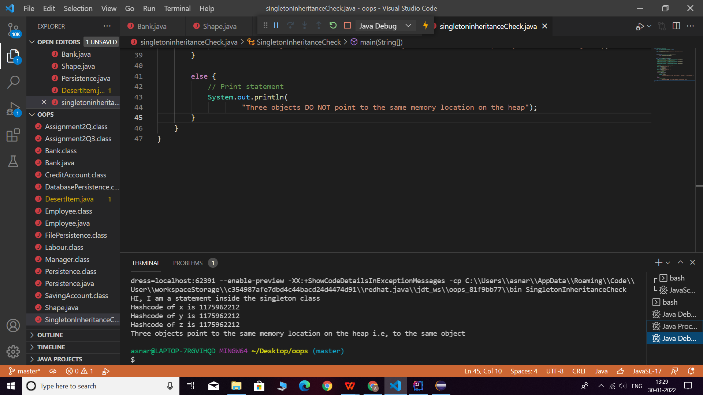

Q2. Write a program that describes the hierarchy of an organization. Here we need to write 3 classes Employee, Manager & Labour where Manager & Labour are the sub classes of the Employee. Manager has incentive & Labour has over time. Add the functionality to calculate total salary of all the employees. Use polymorphism i.e. method overriding.

Description:-

Write a program to claculate the total salaries given to all the employees by an organization. In this organization there are employees category under which Manager and Labour are working where manager will recieve incentive and labourer will receive overtime benifits.

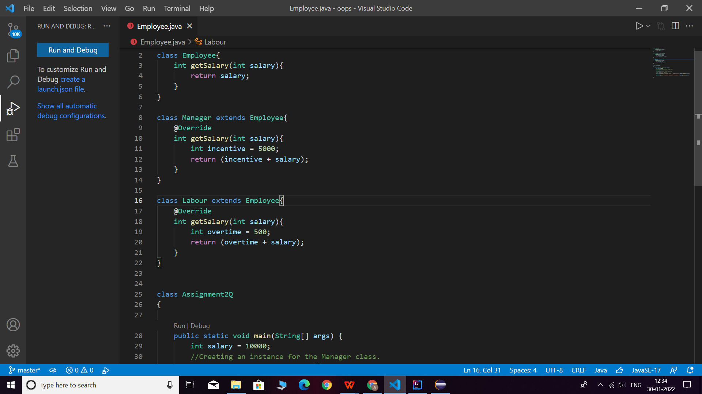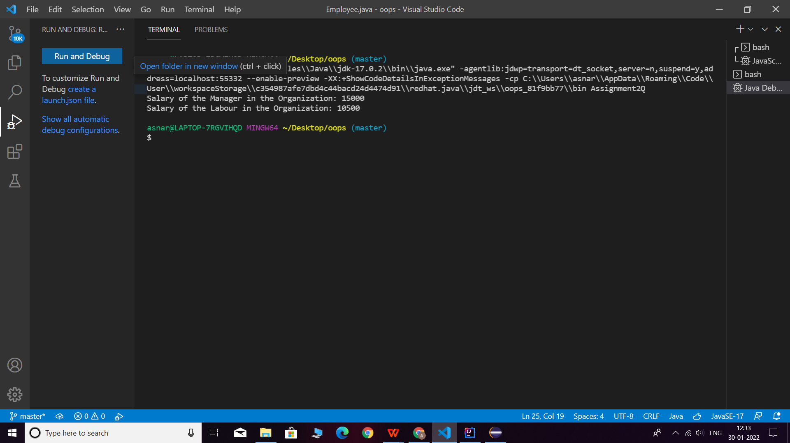

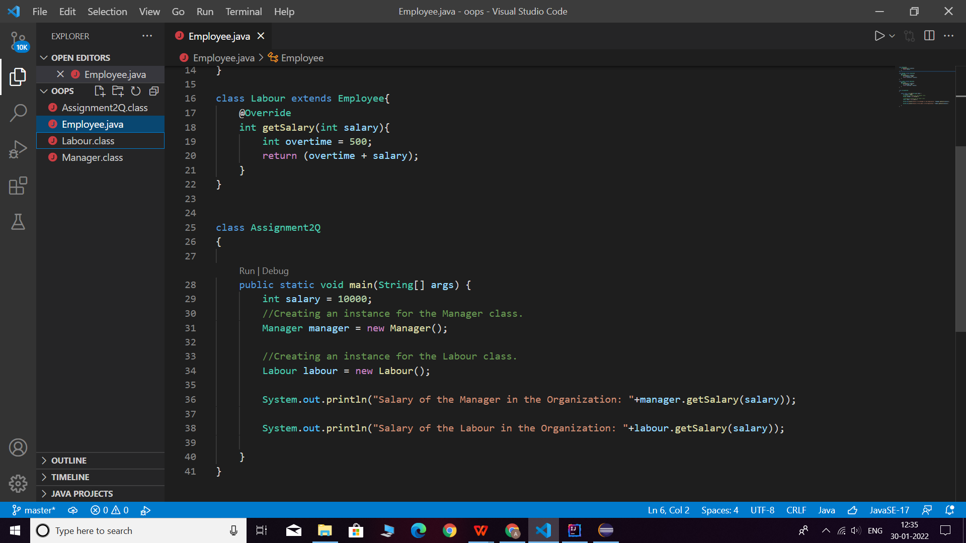

**Q3. Write a program to consider saving & current account in the bank. Saving account holder has ‘Fixed Deposits’ whereas Current account holder has cash credit. Apply polymorphism to find out total cash in the bank.**

**Description: -**Write a program to calculate the total cash available in the bank. In this bank, bank will provide two types of accounts one is savings accounts and another is current account where current account has cash credits and savings account has fixed deposit options.

.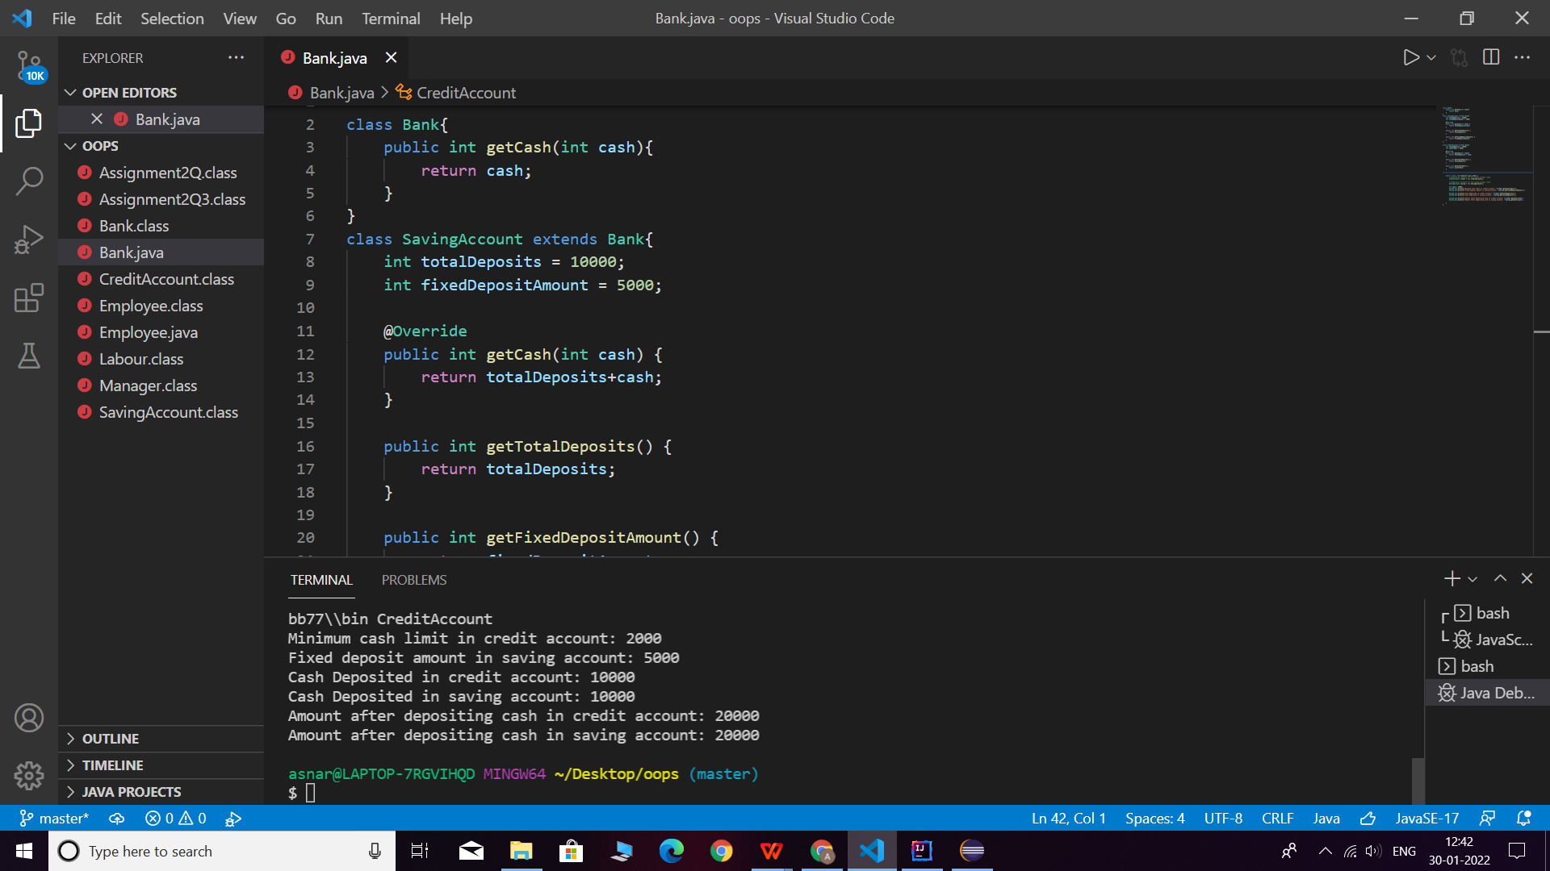

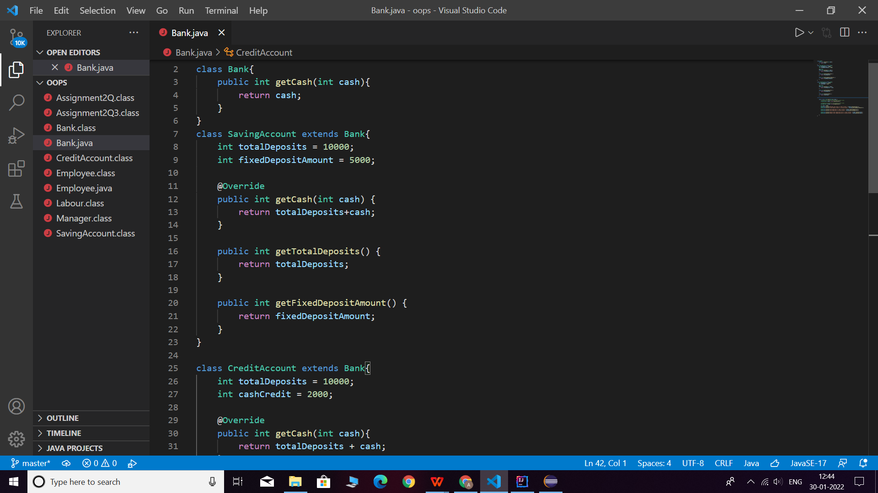  
 }  
}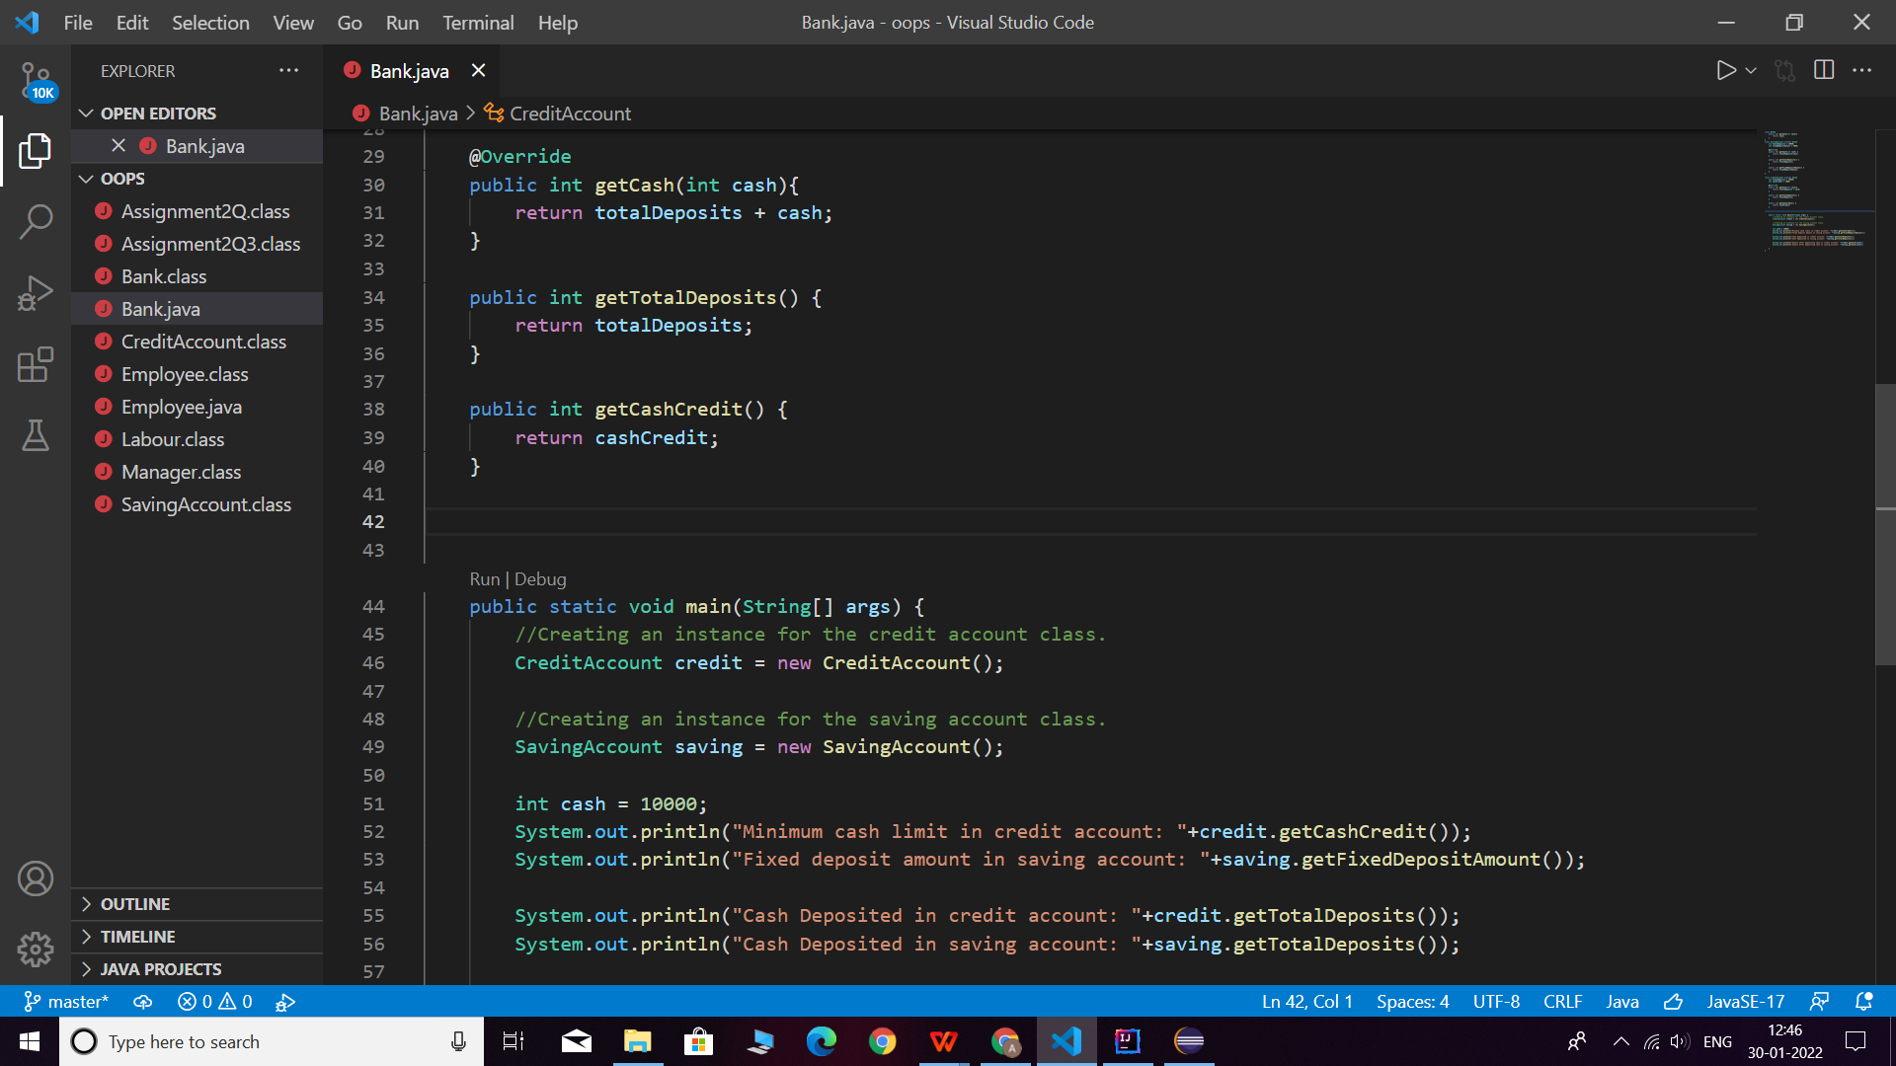

**Q5. Write the classes Line, Rectangle, Cube etc. & make the Shape as their base class. Add an abstract draw() method in the class Shape & draw all shapes.**

**Description:-**

Write a java class named Shape which has abstract draw() and also classes Line, Rectangle, Cube etc. extends Shape to implement the draw method.

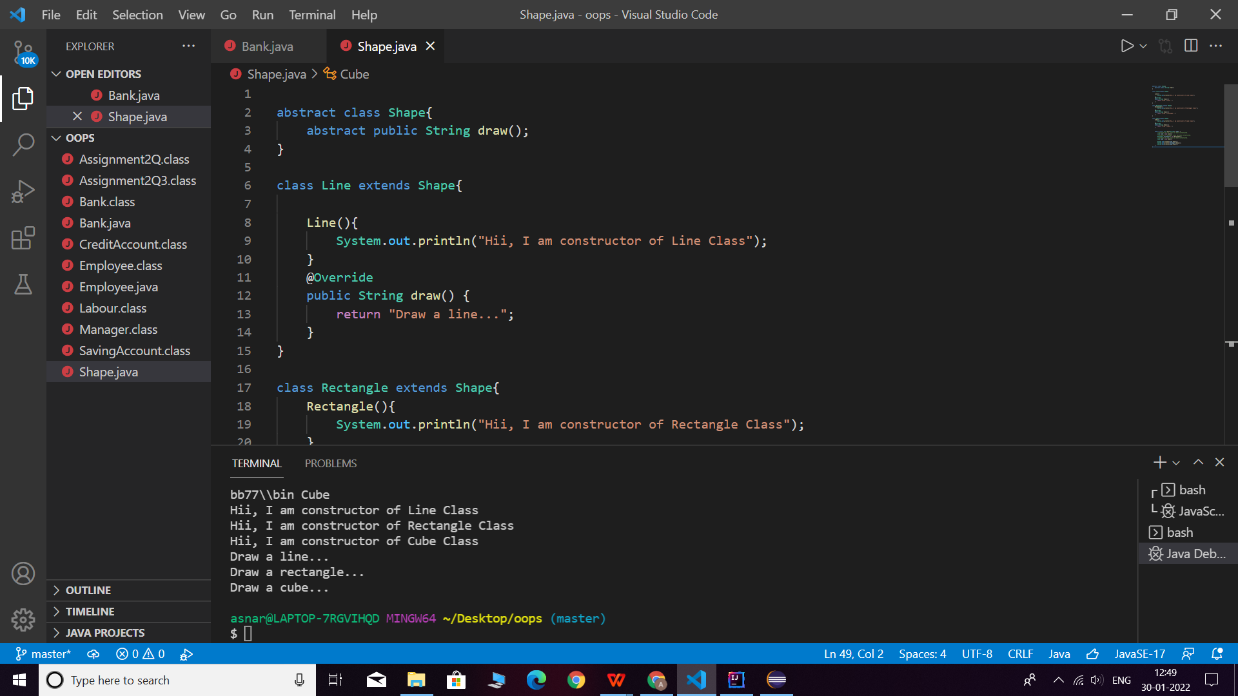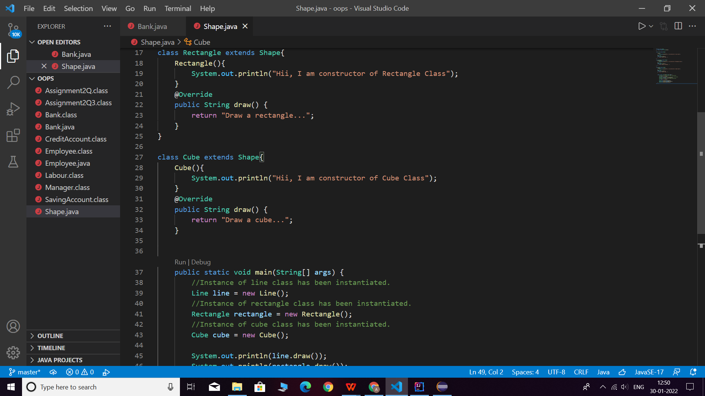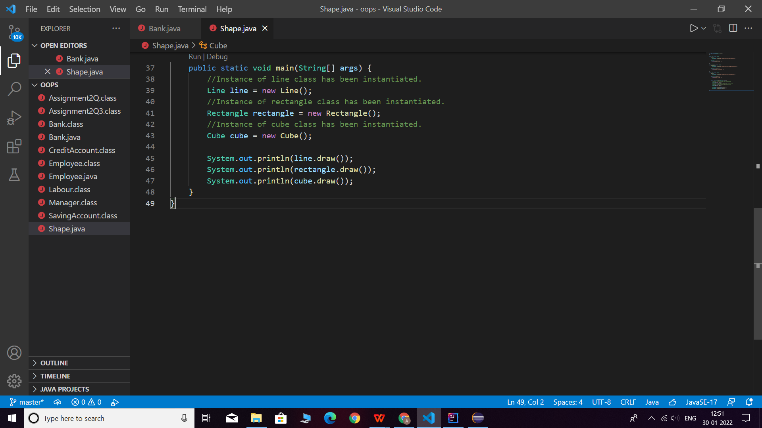

**Q6. Write an abstract class ‘Persistence’ along with two sub classes ‘FilePersistence’ & ‘DatabasePersistence’. The base class with have an abstract method persist() which will be overridden by its sub classes. Write a client who gets the Persistence object at runtime & invokes persist() method on it without knowing whether data is being saved in File or in Database.**

**Description:-**

Write a program having an abstract class "Persistence" which have two child classes "FilePersistence","DatabasePersistence".The base class will have a persist() method and it is overridden by sub classes.wite a seperate class of client which will get persistence object and invoke persist method on it.(Polymorphism).

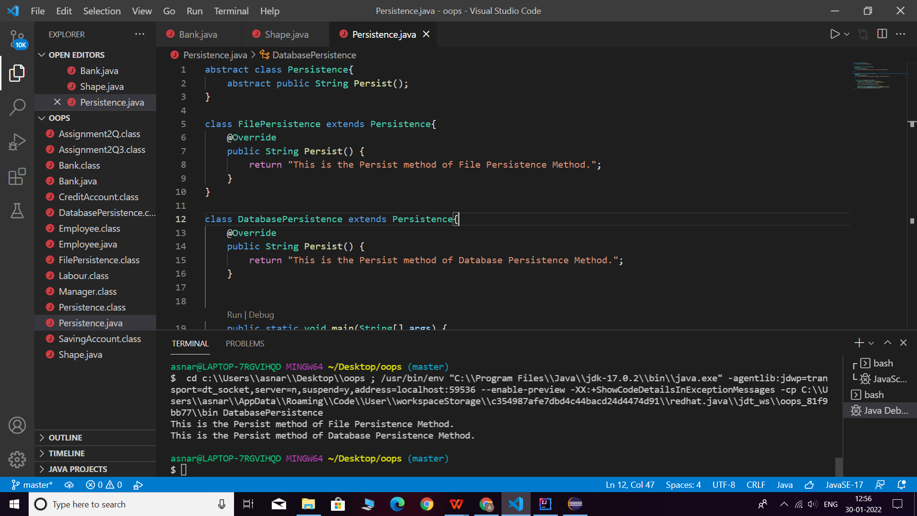

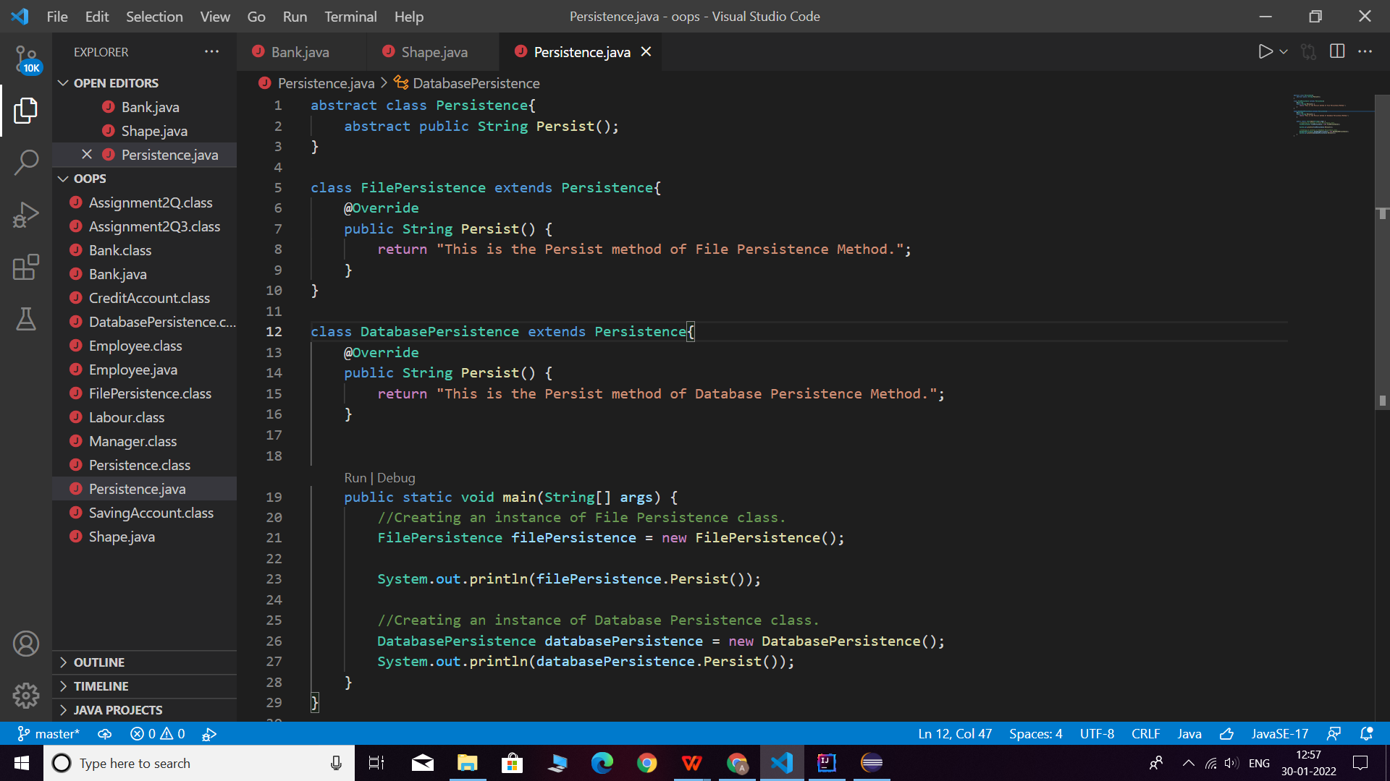

**Q7. Develop an application for Dessert shop. The application should allow owner to add items like Candy, Cookie or Ice Cream in the shop storage. Also, customers should be able to place an order.**

**DessertItem is an abstract class having an abstract method getCost(). Every dessert item has tax associated. Candy item is sold in dollar currency, Cookie in Euro currency & Ice Cream in Rupees currency. The sub classes are supposed to override these methods. When we run the application, it should ask us our role i.e. owner or customer. If role is owner, we should be able to add dessert items in our storage. If role is customer, then we should be able to place an order. The currency conversion rates are:**

**1 dollar = 60 rupees. 1 euro = 70 rupees.**

